The following figure shows the components in a sample card configuration which includes:

+ one or more applications from the Card Issuer;

+ one or more applications from one of the business partners of the Card Issuer, referred to as Application Providers;

+ and one or more applications providing global services (e.g. CVM services) to other applications.

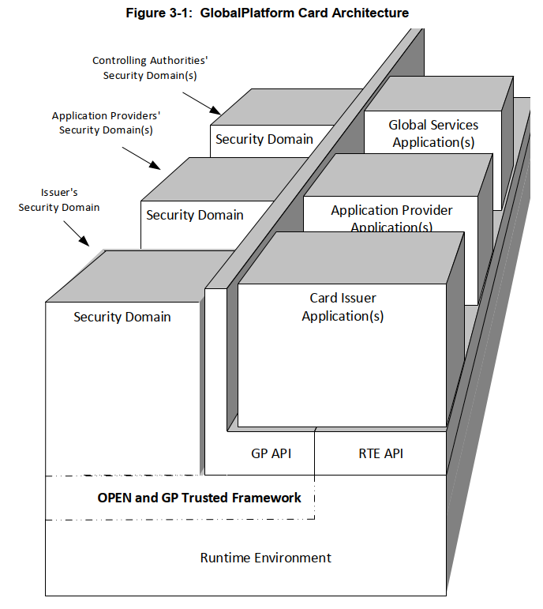

Special key and security management applications called Security Domains are created to ensure complete separation of keys between the Card Issuer and multiple other Security Domain providers.

*--🡪 như vậy lock/unlock app tiến hành thông qua communication giữa off-card entities (GUI để giao tiếp vơi thẻ dạng như JSmart card Explorer) và REs (Globalplatform and JavaCard RE)*

*-🡪* *card and app life cycle (lock/unlock, terminate...) do OPEN (GlobalPlatform Environment) quản lý --🡪 muốn lock/unlock thì phải communicate với OPEN. Ví dụ với Card Issuer:*

*+ Select ISD applet (cần keys)*

*+ Giao tiếp với ISD applet để gọi các API (“ra lệnh”) của OPEN để manage card and app life cycle (lock/unlock, terminate...)*

*(Tham khảo chi tiết: GPC_CardSpecification_v2.3.1, 9.6 Security Management)*